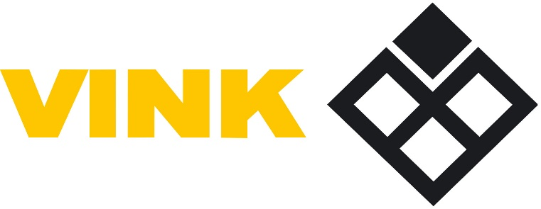

January 1st 2016:
Modern Slavery Act 2015 (the “Act”)
Slavery and Human Trafficking Statement by Vink Uk Ltd (“Vink UK”)
This statement is issued in compliance with S. 54 of the Act.
Vink UK and its associated UK businesses are opposed to slavery and human trafficking.
Our Business
Vink UK is a UK based company that specialises in the distribution of semi-finished plastics and associated products to the signs, display, graphics, industrial, building & construction markets within the UK and Ireland. The business is structured around a series of service centres (30 at this point) that each purchase their own goods from anywhere in the world, to hold in stock and distribute to a very wide customer base. Fifteen of these centres are named as Vink and the others are businesses that trade under another identity but are wholly owned by Vink UK. We are satisfied, from our own due diligence, that there is no evidence of any act of modern slavery or human trafficking within this Company. The due diligence process is ongoing and we will continue to carefully monitor the situation and report accordingly.

Suppliers.
The Vink UK supply chain consists of a range of diverse global manufacturing companies. Wherever possible Vink UK will mainly source goods from the United Kingdom and mainland Europe.
Supplies from other locations will be especially carefully monitored.
Vink UK will not tolerate suppliers utilising slave labour or indulging in human trafficking and will withdraw its purchases from any company proven to be using such practices.
Due Diligence.
To ensure Vink UK does not knowingly purchase from any supplier that uses slave labour, Vink has introduced the following policies from January 2016:-
- All suppliers are required to produce a written statement assuring us that they do not indulge in slavery or human trafficking within their organisation. Their statements are held on file on the Vink intranet for all staff to access.
- This process will be repeated every two years to ensure we retain a continuous assessment approach. Any supplier that does not respond will be assessed for risk and monitored so that potential breaches of the law are mitigated.
- All Vink managers and inventory managers are aware of the applicable law and the need for compliance. There will be an annual anti-slavery update to the training needs of the Company.
- All existing suppliers will be visited and audited for compliance with the laws on slavery and human trafficking. Suppliers will be reminded of their responsibilities and accountability should they fail to respond to the requests for information from Vink UK. Those suppliers who refuse to comply with the law against slavery and human trafficking will be delisted as a supplier. New suppliers will be asked for a written statement of compliance prior to commencement of trading.
- All Company websites will carry this statement in full.
Monitoring / compliance.
- As part of its regular annual meetings a statement will be made on slavery and human trafficking and the steps taken in the previous year to ensure our policies have been complied with.
- All new staff will be advised of the laws on slavery and human trafficking as part of their induction process along with the need for honesty, integrity, and trust in all aspects of their working day.
- Existing staff will be continually updated on the law by their local manager. These updates will form part of the HSE briefing at the monthly centre sales meetings.
- Any whistle blowers will be protected.

